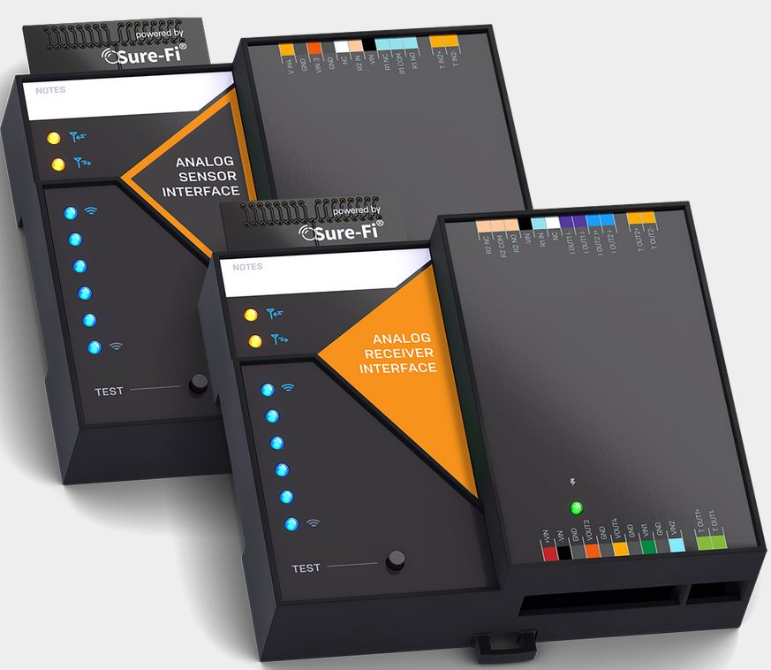

Operators Manual

Doc #PI0254 Rev 1.1

Quick Startup
The two units that are packaged together are factory paired and will only communicate with each other.

Check initial operation
Connect a 9V battery (not included) to the 9V cable (included) and plug the two-position connector in to the ‘+VIN’ and ‘-VIN’ positions on the bottom connector of each unit. Once both units are powered up, the green POWER LED should be ON solid on each unit. Press and quickly release the ‘TEST’ button on either unit to test communication between the two units. One or more of the blue Signal-Strength LEDs should light up for one second to indicate that successful communication has occurred.

Perform a Range-Test from the desired install locations
With the 9V batteries plugged in to each of the units, place them at the desired install location points and perform a Range-Test by pressing and quickly releasing the ‘TEST’ button. The received signal strength is displayed for one second on the six blue LEDs with the bottom LED indicating the minimum signal strength and all six LEDs indicating maximum signal strength.

Connect to permanent power
Before connecting each unit to the permanent power source, ensure that it is in the 12 to 30VAC/VDC range and can source at least 1 ampere. Connect the power at each unit and perform several Range-Tests to check for adequate input power.

Wire the input and output functions
Using this manual as a reference, wire the required devices at each unit.

Table of Contents
Part Numbers |  | Pg. 5
Product Overview |  | Pg. 5
Key Features |  | Pg. 5
General Specifications |  | Pg. 6
Radio Transceiver Specifications |  | Pg. 6
Device Overview, Analog Receiver Interface |  | Pg. 7
Device Overview, Analog Sensor Interface  Receiver Interface – Top & Bottom Connector pin descriptions |  | Pg. 8  Pg. 9
Sensor Interface – Top & Bottom Connector pin descriptions |  | Pg. 10
Analog Channels |  | Pg. 11
Analog and Sampling Ranges, Settings, and Thresholds |  | Pg. 12
Relays: Operating the Relays, Relay Control |  | Pg. 13
Digital Inputs and Outputs (IN 1, IN 2 / OUT 1, OUT 2) |  | Pg. 13
Test (Range Test) Push Button |  | Pg. 13
LEDS: Power, Battery, Tx, Rx |  | Pg. 13
Antenna information |  | Pg. 13
Connector plug information and part numbers |  | Pg. 14
Chaining Multiple systems together for extended range |  | Pg. 14
Mounting |  | Pg. 15
Troubleshooting and manually testing the Relays |  | Pg. 17
Sure-Fi APP, downloading, installing, connecting |  | Pg. 18
Sure-Fi APP: Firmware Updating |  | Pg. 19
Sure-Fi APP: System Heartbeat time  Sure-Fi APP: Setting a Relay default state, timeout, and setting an Alert Relay |  | Pg. 19  Pg. 19
FCC and Industry Canada Regulatory Statements |  | Pg. 20
Warranty |  | Pg. 21

Figure/Table Reference Guide
Figure 1: Device Overview: Receiver Interface |  | Pg. 7
Figure 2: Device Overview: Sensor Interface |  | Pg. 8
Table 1: Receiver Interface Top Edge Connectors P1 and P2 |  | Pg. 9
Table 2: Receiver Interface Bottom Edge Connectors P1 and P2 |  | Pg. 9
Table 3: Senor Interface Top Edge Connectors P1 and P2 |  | Pg. 10
Table 4: Sensor Interface Bottom Edge Connectors P1 and P2 |  | Pg. 10
Table 5: Analog Input Ranges and Settings |  | Pg. 12
Table 6: Analog Output Ranges and Settings |  | Pg. 12
Table 7: Other Input Ranges and Settings |  | Pg. 12
Figure 3: DIN Clips |  | Pg. 15
Figure 4: Top Mounting Screw with DIN clip |  | Pg. 16
Figure 5: Bottom Mounting Screw with DIN clip |  | Pg. 16
Figure 7: Sure-Fi app start screen |  | Pg. 18

Part Numbers
DS007-ANALOG | Analog Bridge system: includes 1 ea. SFI-AB401-01 and SFI-AB402-01
SFI-AB401-01 | Analog Receiver Interface
SFI-AB402-01 | Analog Sensor Interface

Overview
The Sure-Fi DS007-ANALOG Bridge System consists of two units that are factory paired and ready to use out of the box with no configuration required. The system provides a wireless connection (bridge) for analog signals used throughout many industries such as remote monitoring applications, industrial controls, and building automation. The Sure-Fi App provides for configuration, diagnostics, and field firmware updates.

Key Features
- Complete wireless solution for one Form C relay in each direction between units
- Two Analog Voltage (0 – 10V) Inputs/Outputs each direction
- Two Analog Current (4 – 20mA) loops from the Sensor Interface to the Receiver Interface
- Two Resistance (0 – 100K Ohm) inputs (thermistor, rheostat) on Sensor Interface which are converted to 0 -10V linear output on the Receiver Interface.
- One digital input: dry contact or 0 to 5VDC on Sensor Interface
- One digital output on the Receiver Interface which is an open-drain output
- DIN rail mount or direct wall mount using two of the DIN clips
- Sure-Fi App connects via Bluetooth for configuration, diagnostics, and field firmware updates

General Specifications
Operating Voltage: 12 to 30 VAC/VDC
Operating Current: @ 12VDC: 0.05A (idle), 0.3A (transmit)
Operating Power: 3.6 Watt (peak)
Voltage Loop Inputs: Two per unit, 0 – 10V, 0.1% FS
Voltage Loop Outputs: Two per unit, 0 – 10V, 0.1% FS of the input sample
Maximum Output Current: 10mA
Current Loop Inputs: Two inputs on Sensor Interface, 4 – 20mA, 0.1% FS
Loop Voltage output: 24V default, 12V selectable with Sure-Fi App
Current Loop Outputs: Two outputs on Receiver Interface, 4 – 20mA, 0.1% FS
Loop Voltage input range: 7.5 to 24V
Output Load Resistance: 550 Ohms maximum
Resistance Inputs: Two inputs on Sensor Interface, 0 – 100K Ohm input range
Resistance Outputs: Converted to 0 – 10V linear output on Receiver Interface
Digital Input: Digital input on Sensor Interface, 0 – 5VDC max input or dry contact
Digital Output: Digital output on Receiver Interface, open drain (>100 Ω pullup)
Relay Input (R1 IN, R2 IN): 7VAC/VDC minimum turn ON, 30VAC/VDC maximum input
Relays (one per unit): One Form C solid state relay, 2A 30VDC / 30VAC
Input Sample rate: 25 milliseconds maximum
Output Update rate: Update on heartbeat and threshold cross: +/-0.1V, +/-100uA, +/-3.5% Ω. Heartbeat time and thresholds are adjustable with Sure-Fi App.
Range: Up to 1 mile through obstructions. Greater than 50 miles line-of-sight
Multiple system pairs can be connected (“chained”) for extended range
Encryption: AES128
Operating Temperature: -13°F to +158°F (-25°C to +70°C)
Storage Temperature: -40°F to +185°F (-40°C to +85°C)
Humidity: Less than 85% RH (non-condensing)
Dimensions (L x W x H): 3.54” x 4.23” x 1.28” (90mm x 107mm x 32.5mm)
DIN mount type: 35mm DIN rail (DIN46277-3) / (DIN35)
Degree of Protection: IP20 to IEC/EN 60529

Radio Transceiver Specifications
Transmit Power: 1 Watt (30dBm)
Frequency Band: 902 – 928MHz
Channels: 72 (Frequency hopping)
Receiver Sensitivity: -133dBm
Link Budget: 163dB

Device Overview
Figure 1: Overview, Analog Receiver Interface
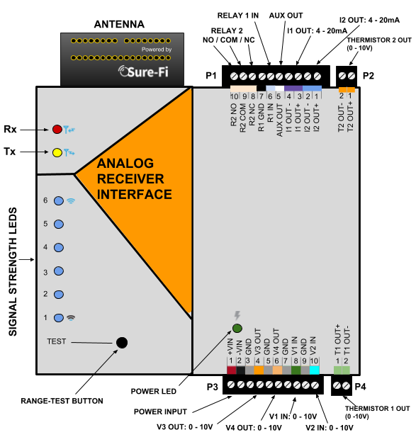

Device Overview
Figure 2: Overview, Analog Sensor Interface
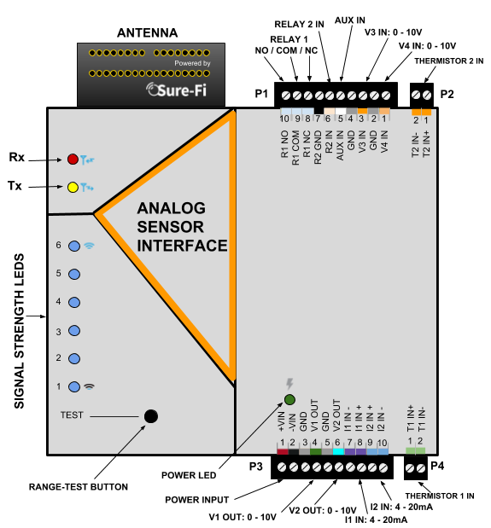

Receiver Interface connectors
Table 1: Top Edge Connectors P1 and P2. See Figure 1 for connecter locations and pin numbers
CONNECTOR | POSITION | NAME | DESCRIPTION
P2 | 1 (right end) | T2 OUT+ | Resistance Channel 2 positive output (0 – 10V)
P2 | 2 | T2 OUT- | Resistance Channel 2 negative (GND)
P1 | 1 | I2 OUT+ | Analog Current Channel 2 Output ‘+’ connection
P1 | 2 | I2 OUT- | Analog Current Channel 2 Output ‘-‘ connection
P1 | 3 | I1 OUT+ | Analog Current Channel 1 Output ‘+’ connection
P1 | 4 | I1 OUT- | Analog Current Channel 1 Output ‘-‘ connection
P1 | 5 | AUX OUT | Digital Output, open drain
P1 | 6 | R1 IN | Relay 1 control, min 7VAC/DC ON, 30VAC/DC max
P1 | 7 | R1 GND | Relay 1 negative
P1 | 8 | R2 NC | Relay 2 Normally-Closed terminal
P1 | 9 | R2 COM | Relay 2 Common terminal
P1 | 10 (left end) | R2 NO | Relay 2 Normally-Open terminal

Table 2: Bottom Edge Connectors P3 and P4. See Figure 1 for connecter locations and pin numbers
CONNECTOR | POSITION | NAME | DESCRIPTION
P3 | 1 (left end) | +VIN | Positive Power Input, DC positive or AC (12 – 30VAC/VDC)
P3 | 2 | -VIN | Negative Power Input, DC negative or AC
P3 | 3 | GND | Signal Ground
P3 | 4 | V3 OUT | Analog Voltage Channel 3 Output (0 -10V)
P3 | 5 | GND | Signal Ground
P3 | 6 | V4 OUT | Analog Voltage Channel 4 Output (0 -10V)
P3 | 7 | GND | Signal Ground
P3 | 8 | V1 IN | Analog Voltage Channel 1 Input (0 -10V)
P3 | 9 | GND | Signal Ground
P3 | 10 | V2 IN | Analog Voltage Channel 2 Input (0 -10V)
P4 | 1 | T1 0UT+ | Resistance Channel 1 positive output (0 – 10V)
P4 | 2 (right end) | T1 OUT- | Resistance Channel 1 negative (GND)

Sensor Interface connectors
Table 3: Top Edge Connectors P1 and P2. See Figure 2 for connecter locations and pin numbers
CONNECTOR | POSITION | NAME | DESCRIPTION
P2 | 1(right end) | T2 IN+ | Resistance Channel 2 input (0 – 100K Ohms)
P2 | 2 | T2 IN- | Resistance Channel 2 input (0 – 100K Ohms)
P1 | 1 | V4 IN | Analog Voltage Channel 4 Input (0 -10V)
P1 | 2 | GND | Signal Ground
P1 | 3 | V3 IN | Analog Voltage Channel 3 Input (0 -10V)
P1 | 4 | GND | Signal Ground
P1 | 5 | AUX IN | Digital Input: 0 – 5V or Dry contact
P1 | 6 | R2 IN | Relay 2 control, min 7VAC/DC ON, 30VAC/DC max
P1 | 7 | R2 GND | Relay 2 negative
P1 | 8 | R1 NC | Relay 1 Normally-Closed terminal
P1 | 9 | R1 COM | Relay 1 Common terminal
P1 | 10 (left end) | R1 NO | Relay 1 Normally-Open terminal

Table 4: Bottom Edge Connectors P3 and P4. See Figure 2 for connecter locations and pin numbers
CONNECTOR | POSITION | NAME | DESCRIPTION
P3 | 1 (left end) | +VIN | Positive Power Input, DC positive or AC (12 – 30VAC/VDC)
P3 | 2 | -VIN | Negative Power Input, DC negative or AC
P3 | 3 | GND | Signal Ground
P3 | 4 | V1 OUT | Analog Voltage Channel 3 Output (0 -10V)
P3 | 5 | GND | Signal Ground
P3 | 6 | V2 OUT | Analog Voltage Channel 4 Output (0 -10V)
P3 | 7 | I1 IN- | Analog Current Channel 1 Input ‘-’ connection
P3 | 8 | I1 IN+ | Analog Current Channel 1 Input ‘+‘ connection
P3 | 9 | I2 IN+ | Analog Current Channel 2 Input ‘+‘ connection
P3 | 10 | I2 IN- | Analog Current Channel 2 Input ‘-’ connection
P4 | 1 | T1 0UT+ | Resistance Channel 1 positive output (0 – 10V)
P4 | 2 (right end) | T1 OUT- | Resistance Channel 1 negative (GND)

Analog Channels
Analog Voltage:
There are two analog voltage channels that go in each direction between the Sensor Interface unit and the Receiver Interface unit. The analog voltage channels are default at 0 – 10V and can be set using the Sure-Fi App to any range between 0 – 10.8V. See Tables 6, 7, and 8 for further information on the analog settings, ranges, and defaults.
Analog Current:
There are two analog current channels that go from the Sensor Interface unit to the Receiver Interface unit.
Connecting a 4-20mA sensor:
A 4-20mA sensor connects to the Sensor Interface unit and the Receiver Interface unit connects to the Receiver/PLC/SCADA system. The 4-20mA connection on the Sensor Interface unit provides +24V for loop powered sensors and does not require and external loop voltage source. The loop voltage is defaulted at +24V and can be set to +12V with the App. See Tables 6, 7, and 8 for further information on the analog settings, ranges, and defaults.
Resistance:
There are two resistance inputs on the Sensor Interface unit that are converted to a linear output 0 – 10VDC at the Receiver Interface unit. The Receiver Interface 0 – 10VDC output is a linear representation of the 0 – 100K Ohm input where 0V = 0 Ohms, 5.0V = 50K Ohm, and 10.0V = 100K Ohm. The multiplier is 10,000. For example, if the voltage reads 0.5V, the resistance = 5000 Ohms (0.5 x 10,000 = 5000). See Tables 6, 7, and 8 for further information on the analog settings, ranges, and defaults.

Analog and Sampling Ranges, Settings, and Thresholds

Table 5: Analog Input Ranges and Settings:
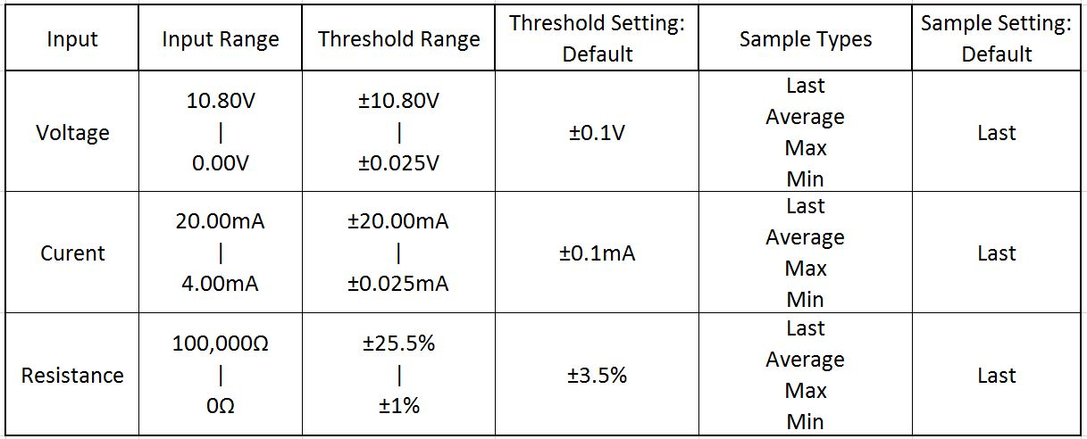
Table 6: Analog Output Ranges and Settings:
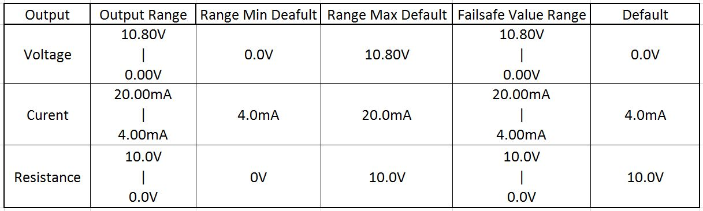
Table 7: Other Ranges and Settings:
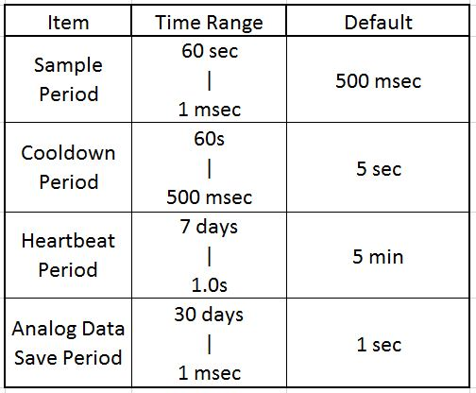

Relays
Operating the relays:
The Form C relay on each unit is operated by the corresponding relay input on the paired unit. For example, to activate Relay 1 on the Sensor Interface, the Relay 1 input (R1 IN) on the Receiver must be connected to a minimum of 7VAC/VDC.

Relay control:
Relay 1 (R1 NO, R1 COM, R1 NC) located on the Sensor Interface is operated by R1 IN on the Receiver Interface
Relay 2 (R2 NO, R2 COM, R2 NC) located on the Receiver Interface is operated by R2 IN on the Sensor Interface

Digital Input/Output (AUX IN / AUX OUT)

The AUX IN on the Sensor Interface corresponds to the AUX OUT on the Receiver Interface. The input is interfaced by shorting AUX IN to GND using either a dry contact or interfacing with a digital voltage input which can be 0 to 3.3VDC or 0 to 5VDC.

The ‘Test’ Push-Button (Range Test)
Range Test: Pressing and releasing the ‘Test’ button quickly initiates the Range Test. The Range Test feature is used to test the signal strength of the radio transceiver with the paired unit and displays the results of a received transmission on the six blue LEDs, these are labeled ‘Signal Strength LEDS (1 – 6)’ in Figure 1. Maximum signal strength is indicated when LEDs 1 through 6 all flash ON and minimum signal strength is indicated when only LED 1 flashes ON.

LEDS (Refer to Figure 1)
- POWER LED: LED will be ON solid indicating that power is present.
- Rx LED: The Rx LED will flash ON once briefly when a Sure-Fi radio transmission is received.
- Tx LED: The Tx LED will flash ON once briefly upon a radio transmission. The Tx LED will flash ON only on the unit that initiates the transmission.

Antenna
The radio antenna is created using copper traces on both sides of the PC Board. Use caution when handling and mounting the unit to ensure that no damage (scratches, etc.) occurs to the PC Board/Antenna. Additionally, for best performance, keep cables and wiring away from the antenna and mount the unit oriented with the antenna upwards.

Connectors
The connectors are 3.5mm EURO type. For the 10 position connectors, P1 and P3, the mating plug is Molex pn 39500-0010. For the 2 position connectors, P2 and P4, the mating plug is Molex pn 39500-0002.

Wire Range: 16 to 30AWG stranded or solid. Wire strip length 0.250”. Recommended screwdriver: slotted blade 0.98” (2.5mm) width. To install a wire, turn the screw counter-clockwise 3 or 4 turns, insert the wire and hold in place while tightening the screw. When complete, pull on the wire to ensure that it is tightened adequately.

Chain multiple system pairs for extended range
If a single paired system is unable to communicate from the desired two endpoints, a second paired system can be used to create a ‘chain’ to extend the range. If required, many paired systems can be ‘chained’ together for extremely difficult installations. To accomplish this, the Receiver Interface of the first system is wired to the Sensor Interface of the next system with the inputs of each unit connected to the outputs of the other unit. This does not work for the Resistance channels T1 IN and T2 IN.

Mounting
DIN Rail mount:
DIN rail mounting allows the unit to easily clip and unclip from the DIN rail. Attach a piece (minimum 4” length) of 35mm type DIN rail to the wall and then snap the unit to the DIN rail or slide it on from the end. The unit will snap in to place by putting the top retaining tabs on to the DIN rail first, then pressing the bottom on to the DIN rail until it snaps in to place, the bottom DIN clip may need to be pressed upward to seat into its locked position. To remove the unit from the DIN rail, use a small screwdriver, insert in to the bottom DIN rail clip and pull gently down and outward until the unit releases from the DIN rail.

Screw mount:
The DIN rail clips on the base of the enclosure case can be snapped outward to allow for screw mounting of the case. Mount using only the single bottom DIN clip and the top DIN clip that is located on the side below connector P1. Do not use the DIN clip located behind the antenna. See Figures 5, 6, and 7.

If mounting the unit to metal, take note that metal shavings that are created can drop into the unit and damage the electronics. To avoid any metal shavings from dropping down in to the case, it is recommended to remove the top DIN clip completely from the base and secure it to the wall first, then slide the case on to the DIN clip. The second screw can then be secured through the bottom DIN clip without removing the clip. #8 self-drilling screws are recommended. Do not use a fastener that is larger than a #8 size.

Figure 3: The two DIN clips are shown pressed outward and ready for screw mounting:
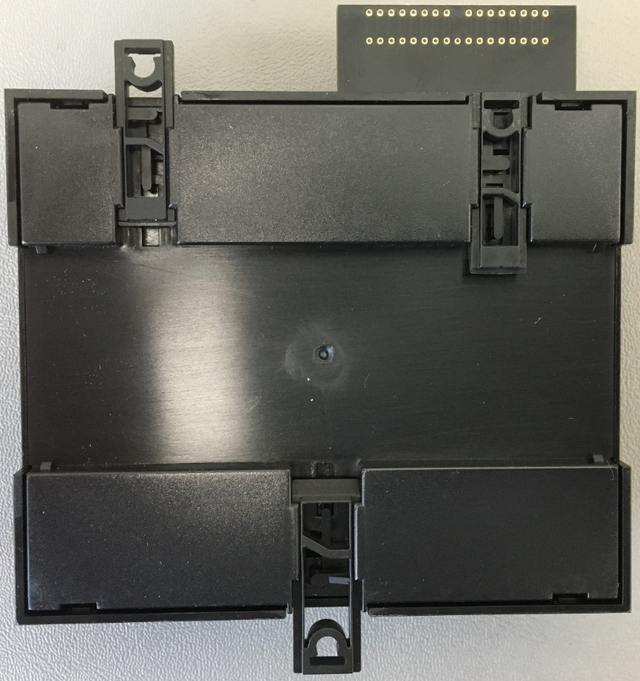

Figure 4: The top screw is shown mounted through the DIN clip to the wall:
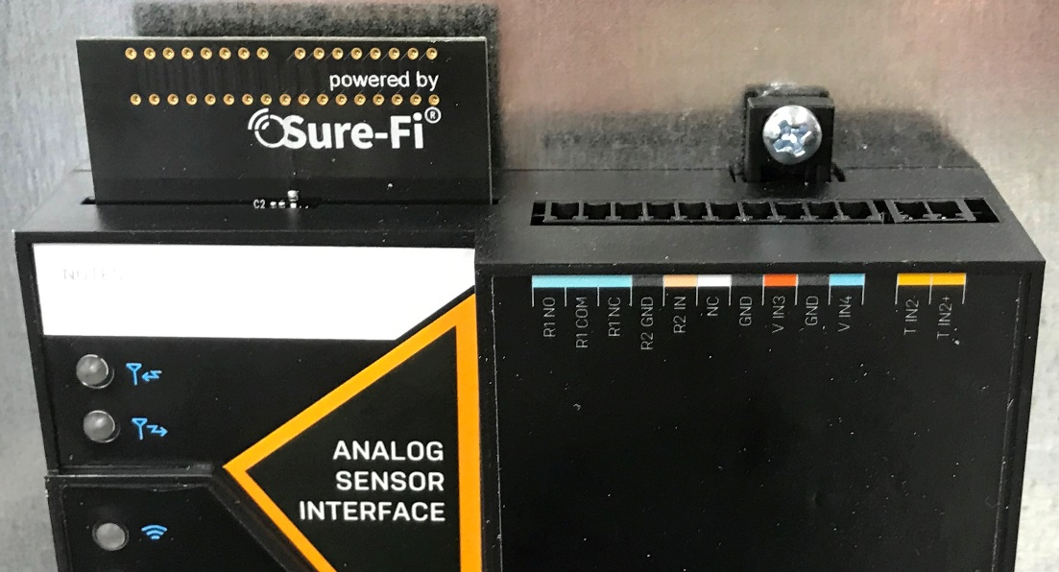

Figure 5: The bottom screw is shown mounted through the bottom DIN clip to the wall:
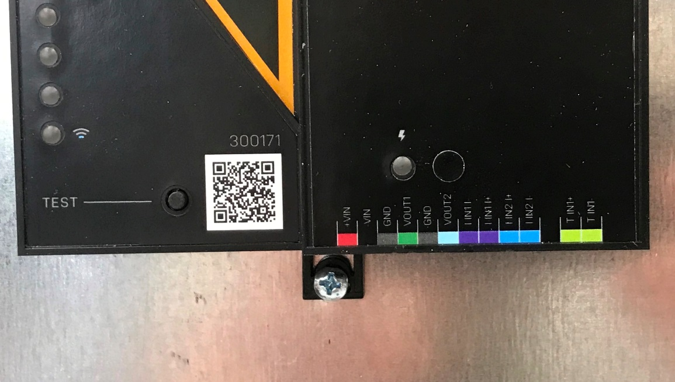

Troubleshooting
Testing Range and RF communications:
Press and release quickly the ‘Test’ button on one of the units and observe the six Signal Strength LEDs. If any of the blue LED 1 through LED 6 lights up momentarily then the transmission between the two units was successful. This establishes that the radio communications between the two units is operational and even with only LED 1, there is adequate signal strength for proper function.

For the best range performance between the two units:
- Power both units with their own dedicated power supply capable of 3.6 Watts.
- Route all cables and wiring away from the area near the Antenna.
- Avoid routing cables and wiring over the top of the unit.
- Mount both units oriented with the antenna at the top of the unit facing upwards.
- Rotating either (or both) of the units may provide an improvement in range.
- If additional range is required, avoid placing either unit on or near metal and place each unit at a higher location.

Manually Testing Relays:
Each Relay pair can be manually tested to verify operation. Using a jumper wire, short the Relay input (R1 IN or R2 IN) to the +VIN power input terminal on connector P3 Pin 1. Then check the Relay OUTPUT on the paired unit to ensure that it is energized. The relays are solid state and so a ‘click’ sound will not be heard when the relay energizes, a meter or a device would need to be connected to verify relay activation.

Sure-Fi App
The Sure-Fi App for iOS and Android allows for adjusting settings, updating firmware, as well as for some diagnostics and troubleshooting information. The App is continually being updated to provide for more information and features and to improve its ease of use. To download, search for ‘Sure-Fi’ and then download and install. The key features of the App are:
- Setting the analog input thresholds, range and sample type
- Setting the analog output range and fail-safe settings
- Setting default relay output state upon a set timeout interval (in increments of the Heartbeat time)
- Setting the Sample Period, Cooldown Period, and the Analog Data Save period
- Setting the system Heartbeat time.
- Field firmware updates if required
- Configure the six Signal Strength LED indicators for ON/OFF, persistence time
- Diagnostics and troubleshooting: can set any output to known values/states
- Access to documentation (Operators Manual, Application Notes, Reference documents, etc.)

Figure 6: Sure-Fi App start screen

Using the Sure-Fi App
Connecting:
The Sure-Fi App uses the Bluetooth on the user’s phone to connect to the Analog Bridge’s onboard Bluetooth interface. To use the App, be sure that the unit is powered ON, then open the App, then scan the QR code that is on the unit next the ‘TEST’ button (see Figure 6). The Status will show ‘Connecting’, then after a pause it will say “Hold Test button on the Bridge for 5 seconds”. If the connection is successful, the status will show ‘Status: Connected’ and all the features of the App will be available for use.
Firmware Updating
Firmware updates must be completed on both units when updating the firmware. The Bridge pair may operate erratically or be non-functional until both sides have been updated to a new firmware version. If updating firmware on one side, plan to immediately go to the other side and perform the same firmware update.

A data connection must be available on the device (phone) that the Sure-Fi App is running on. Be sure that the APP remains connected to the Bridge unit during the update process which usually takes a couple minutes to complete. After connecting to the Bridge unit with the App, select ‘Update Firmware’ from the menu. The ‘Update Firmware’ screen will show the current firmware versions and show if a newer released version is available. Select ‘Start Firmware Update” to begin the updating process. A notification will be given when the update is complete.

Setting the System Heartbeat time
The system Heartbeat is the time interval when the system will automatically perform a system status check if there have not been radio communications between the units during that time. The Heartbeat timer is reset each time any successful transmission occurs between units during regular usage. The Heartbeat system status check verifies communication between units and that all output states correspond correctly with the given inputs. If a unit does not receive the Heartbeat, it will continue to attempt communications and it will keep all outputs set at their current state unless any of the outputs have been set for fail-safe values using the App. In that case, the unit will set the output values as configured when the set time interval is reached. The Heartbeat time interval and the number of Heartbeats that can be missed are configurable with the App.

Setting a Relay default state, timeout, and setting an Alert Relay
This feature is defaulted from the factory as disabled. With Relay default state disabled, the relays will remain in their current state during any time that communications with the paired unit are interrupted. The relays can be set to default as activated or deactivated after a set time interval has passed if communication with the paired unit is interrupted. The time interval is based on multiples of the Heartbeat time. When the time interval is reached, the relay(s) will go to the selected default state (activated or deactivated) as configured in the App and will remain in that state until regular system activity returns. This feature provides a way to define the relay default state if communications between units is interrupted for a period of one or more Heartbeat time intervals and allows for a way to have a relay to be set as an ‘Alert’ Relay to indicate RF communications interruption.

FCC and Industry Canada Regulatory Statements
FCC
This device complies with part 15 of the FCC rules. Operation is subject to the following two conditions: (1) This device may not cause harmful interference, and (2) this device must accept any interference received, including interference that may cause undesired operation. Any changes or modifications not expressly approved by manufacturer could void the user’s authority to operate the equipment.

IMPORTANT! Any changes or modifications not expressly approved by the party responsible for compliance could void the user’s authority to operate this equipment.

Industry Canada
This device complies with Industry Canada license-exempt RSS standard(s). Operation is subject
to the following two conditions: (1) this device may not cause interference, and (2) this device
must accept any interference, including interference that may cause undesired operation of the
device.

Le présent appareil est conforme aux CNR d’Industrie Canada applicables aux appareils radio exempts de licence. L’exploitation est autorisée aux deux conditions suivantes: (1) l’appareil ne doit pas produire de brouillage, et (2) l’utilisateur de l’appareil doit accepter tout brouillage radioélectrique subi, meme si le brouillage est susceptible d’en compromettre le fonctionnement.

IMPORTANT! Tous les changements ou modifications pas expressément approuvés par la partie responsable de la conformité ont pu vider l’autorité de l’utilisateur pour actioner cet équipment.

47 CFR 15.105- FCC
NOTE: This equipment has been tested and found to comply with the limits for a Class B digital device, pursuant to part 15 of the FCC Rules. These limits are designed to provide reasonable protection against harmful interference in a residential installation. This equipment generates, uses and can radiate radio frequency energy and, if not installed and used in accordance with the instructions, may cause harmful interference to radio communications. However, there is no guarantee that interference will not occur in a particular installation. If this equipment does cause harmful interference to radio or television reception, which can be determined by turning the equipment off and on, the user is encouraged to try to correct the interference by one or more of the following measures:

—Reorient or relocate the receiving antenna.
—Increase the separation between the equipment and receiver.
—Connect the equipment into an outlet on a circuit different from that to which the receiver
is connected.
—Consult the dealer or an experienced radio/ TV technician for help.

This Class B digital apparatus complies with Canadian ICES-003.
Cet appareil numérique de la classe B est conforme à la norme NMB-003 du Canada

FCC Radiation Exposure Statement
This equipment complies with FCC radiation exposure limits set forth for an uncontrolled environment. This equipment should be installed and operated with minimum distance 20cm between the radiator and your body.

Important Note:
Radiation Exposure Statement:
This equipment complies with IC radiation exposure limits set forth for an uncontrolled environment. This equipment should be installed and operated with minimum distance 20cm between the radiator and your body.

Note Importante: (Pour l’utilisation de dispositifs mobiles)
Declaration d’exposition aus radiations:
Cet équipement est conforme aux limites d´exposition aux rayonnements IC établies pour un environnement non contrôlé. Cet équipment doit être installé et utilisé avec un mimimum de 20 cm de distance entre la source de rayonnement et votre corps.

Warranty
The warranty period of this product is 12 months run-time, beginning from first power up of the device after purchase. During this period, if the product does not operate correctly, due to a defective component, the product will be repaired or replaced at the sole discretion of Sure-Fi, Inc. This warranty does not extend to the product casing which can be damaged by conditions outside of the control of Sure-Fi, Inc.

EXCEPT AS SET FORTH ABOVE, SURE-FI, INC. MAKES NO WARRANTIES REGARDING THE GOODS, EXPRESS OR IMPLIED, INCLUDING WARRANTY OF MERCHANTABILITY OR WARRANTY OF FITNESS FOR A PARTICULAR PURPOSE. BUYER MAKES NO RELIANCE ON ANY REPRESENTATION OF SURE-FI, INC., EXPRESS OR IMPLIED, WITH REGARD TO THE GOODS AND ACCEPTS THEM “AS-IS/WHERE-IS”. SURE-FI, INC SELLS THE GOODS TO BUYER ON CONDITION THAT SURE-FI, INC. WILL HAVE NO LIABILITY OF ANY KIND AS A RESULT OF THE SALE. BUYER AGREES THAT SURE-FI, INC. SHALL HAVE NO LIABILITY FOR DAMAGES OF ANY KIND, WHETHER DIRECT, INCIDENTAL OR CONSEQUENTIAL DAMAGES, INCLUDING INJURIES TO PERSONS OR PROPERTY, TO BUYER, ITS EMPLOYEES OR AGENTS, AS A RESULT OF THE SALE. BUYER ALSO AGREES TO HOLD SURE-FI, INC. HARMLESS FROM ANY CLAIMS BUYER, OR ANY THIRD PARTY, MAY HAVE AS A RESULT OF BUYER’S USE OR DISPOSAL OF THE GOODS. BUYER HAS READ THIS DISCLAIMER AND AGREES WITH ITS TERMS IN CONSIDERATION OF RECEIVING THE GOODS.

Trademarks
Sure‐Fi and the Sure‐Fi logo are registered trademarks.

Copyrights
©2019 Sure‐Fi, Inc. All rights reserved.

